Accident Analysis Software User Manual

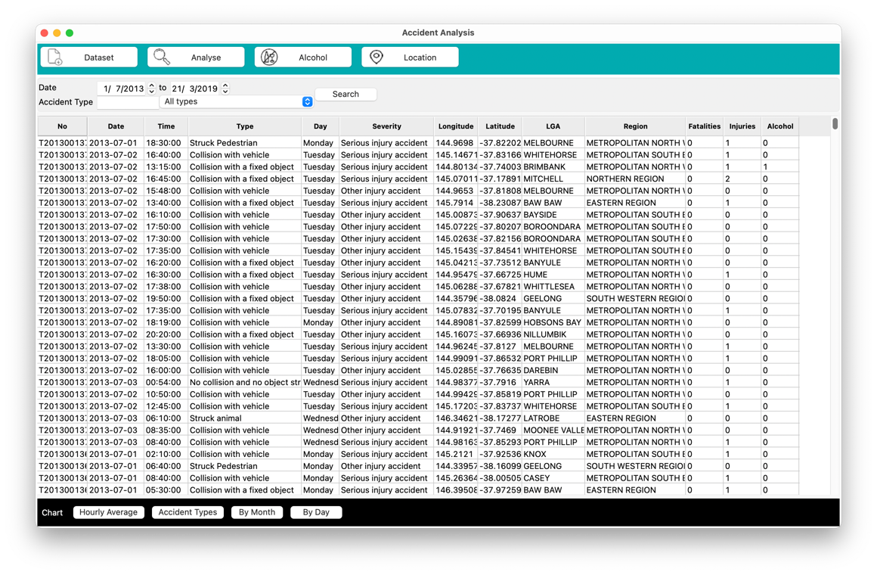

Table of Contents

Setting Up: 3

Requirements: 3

Launching the software 3

Select a Dataset by clicking the ‘Dataset’ button 3

Navigate to desired dataset and click ‘open’ 4

Clearing dataset 5

Analyse Dataset: 6

Click on each date and use the UP/DOWN buttons to navigate to desired date 6

Type desired Accident Type 6

Alternatively, select an Accident Type via the drop-down menu 7

Explore Chart Options for All Incidents 8

Chart Examples 9

Hourly Average Chart 9

Accident Type Chart 9

By Month Chart 10

By Day Chart 10

Analyse Dataset: Alcohol 11

Click on Alcohol button 11

Explore Chart Options for Alcohol Related Incidents 11

Chart Examples 12

Hourly Average chart including alcohol related incidents 12

Accident Types chart including alcohol related incidents 12

By Month chart including alcohol related incidents 13

By Day chart including alcohol related incidents 13

Analyse Dataset: Location 14

Explore Chart Options for All Incidents via Location 14

Chart Examples 15

Top 10 LGA Chart 15

Region Chart 15

Map Chart 16

# Setting Up:

## Requirements:

Ensure before using the software, you have the following libraries installed:

* Pandas
* WxPython
* Numpy
* Matplotlib
* Pycsvschema
* Sqlite3
* Distutils
* Wsgiref
* Python 3.7

## Launching the software

Open a command line application such as Terminal and move to ‘app’ directory that contains files for this software. Prompt the following command.

pythonw main.py

This should open the software.

## Select a Dataset by clicking the ‘Dataset’ button

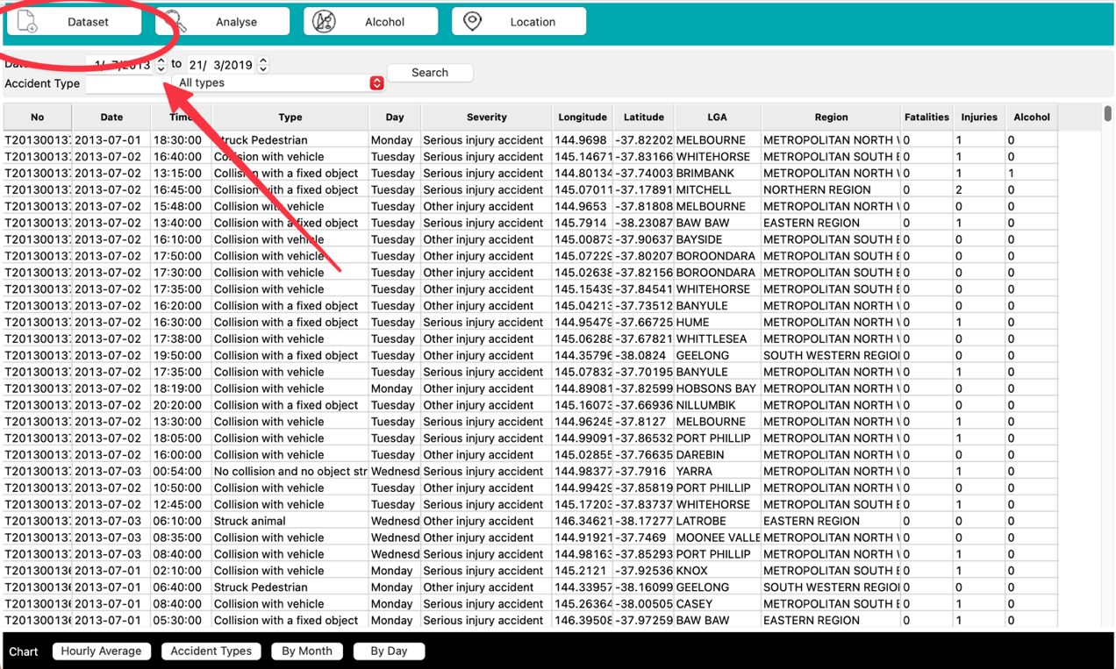

## Navigate to desired dataset and click ‘open’

The file should be a comma separated CSV file containing required columns.

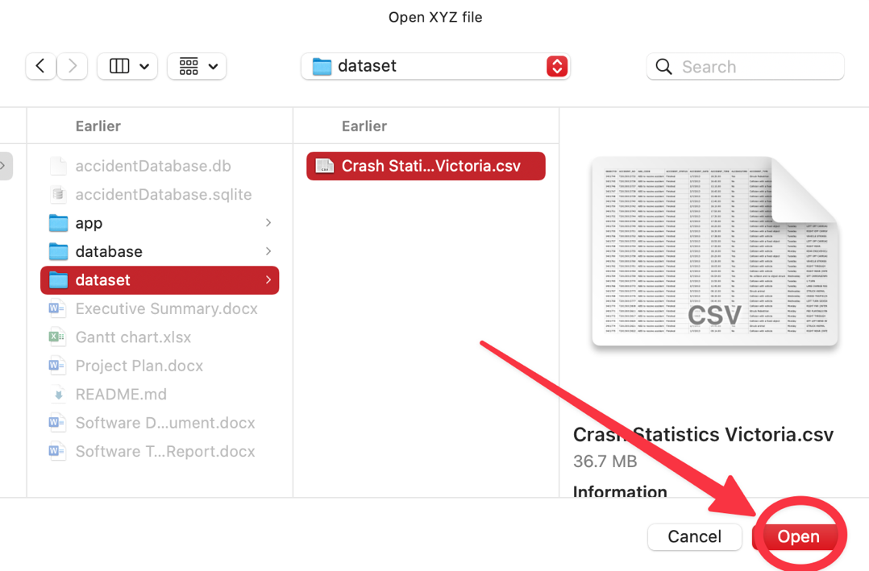

The CSV file will be converted and saved in the local database.

By selecting a new file from clicking “Dataset”, the dataset can be updated with the new dataset file.

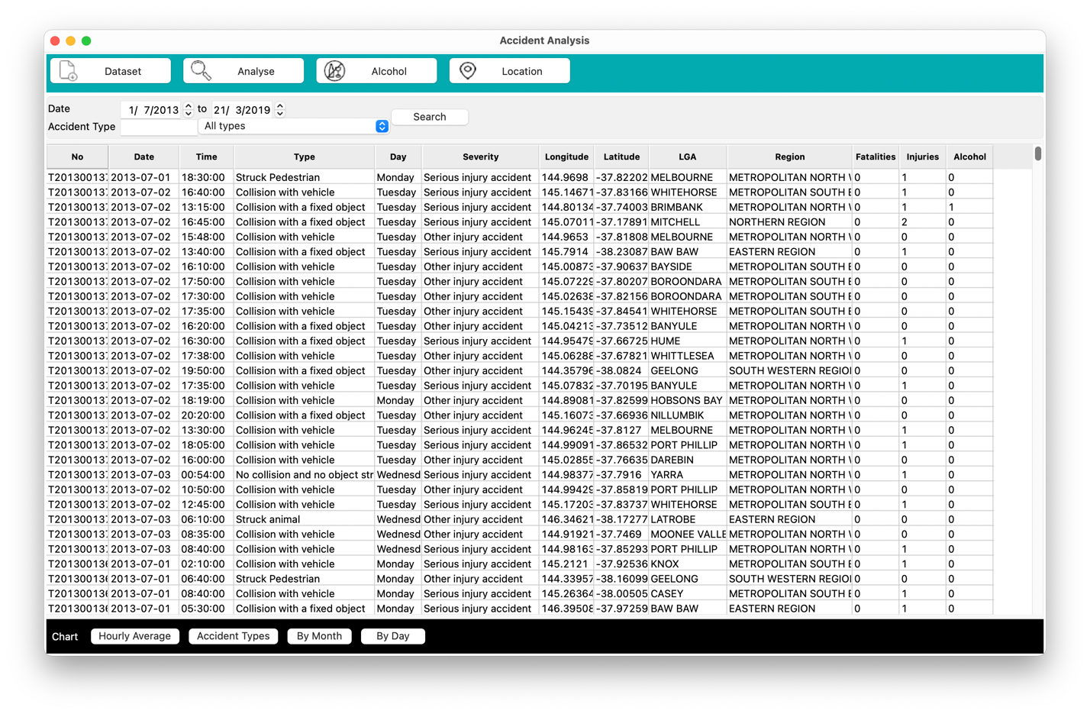

## Clearing dataset

By selecting “Clear Dataset” from the File menu, dataset will be cleared.

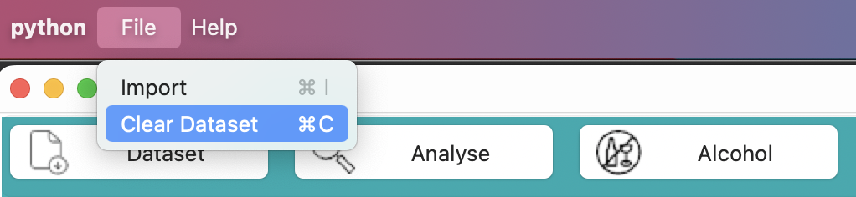

# Analyse Dataset:

## Click on each date and use the UP/DOWN buttons to navigate to desired date

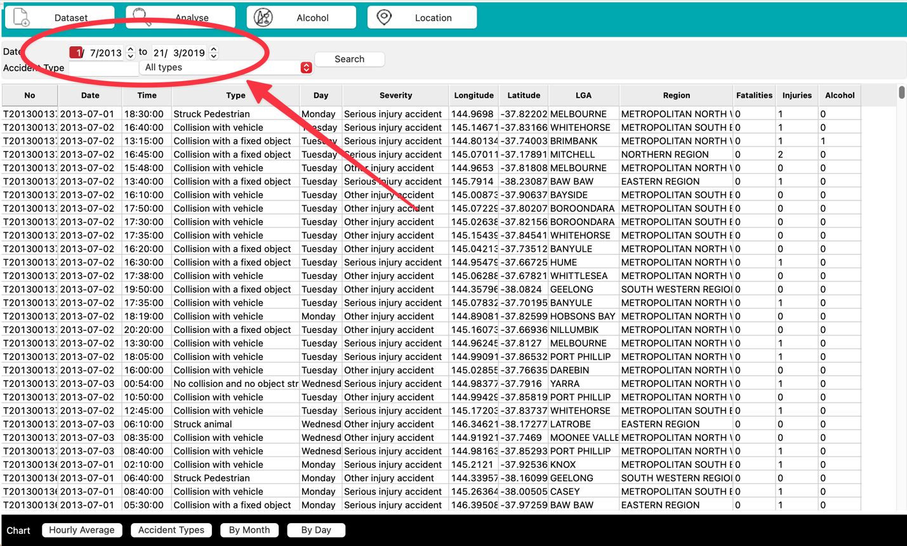

## Type desired Accident Type

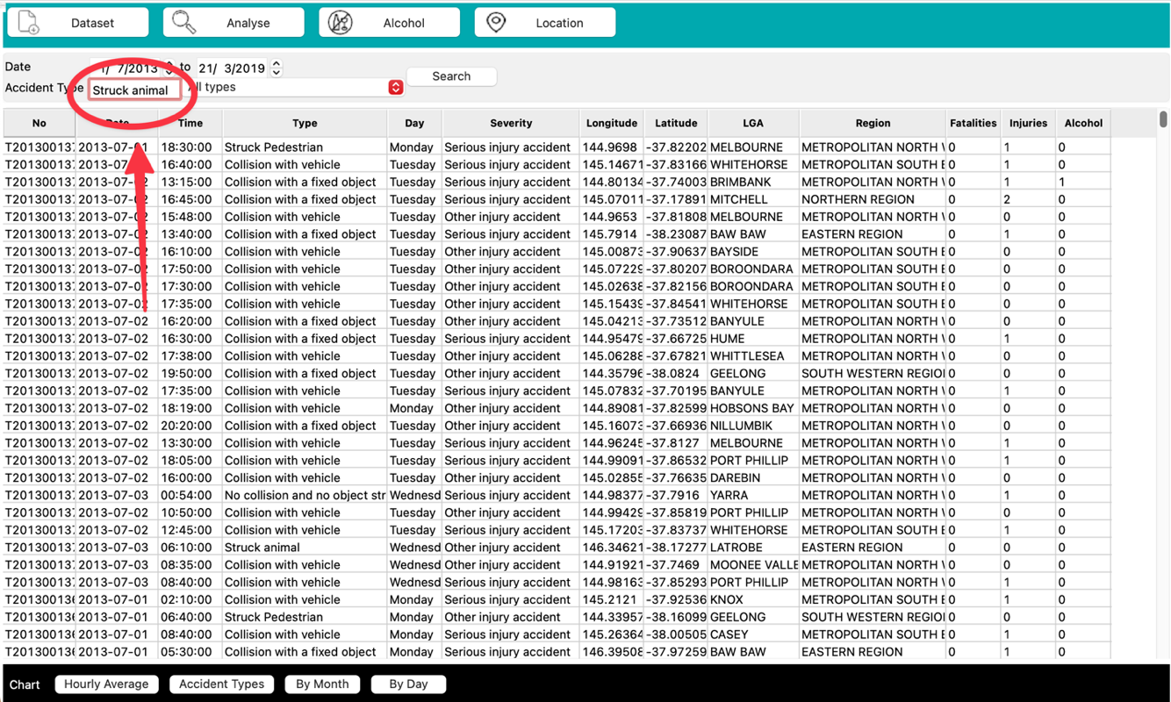

## Alternatively, select an Accident Type via the drop-down menu

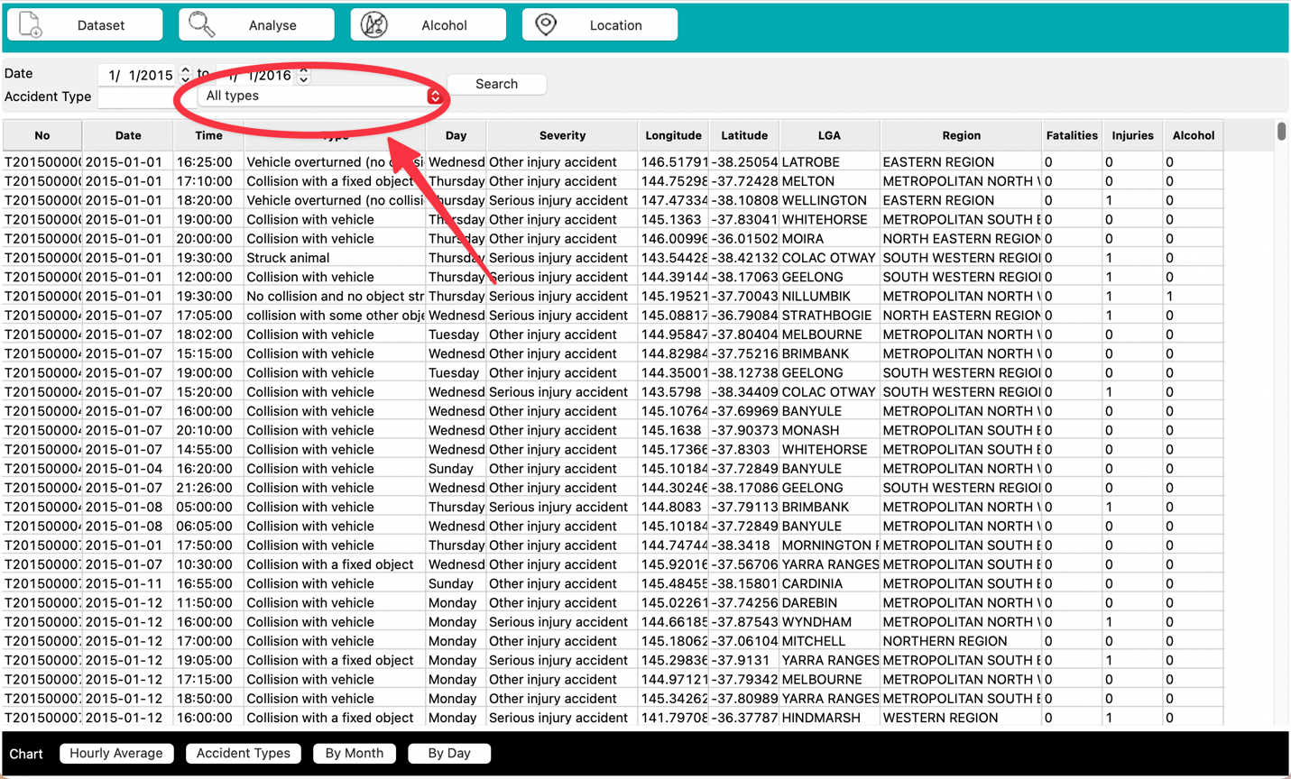

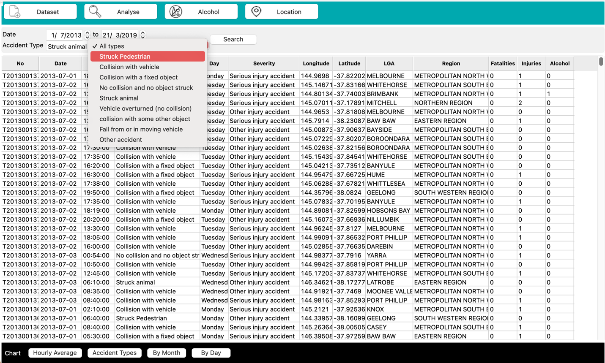

## Explore Chart Options for All Incidents

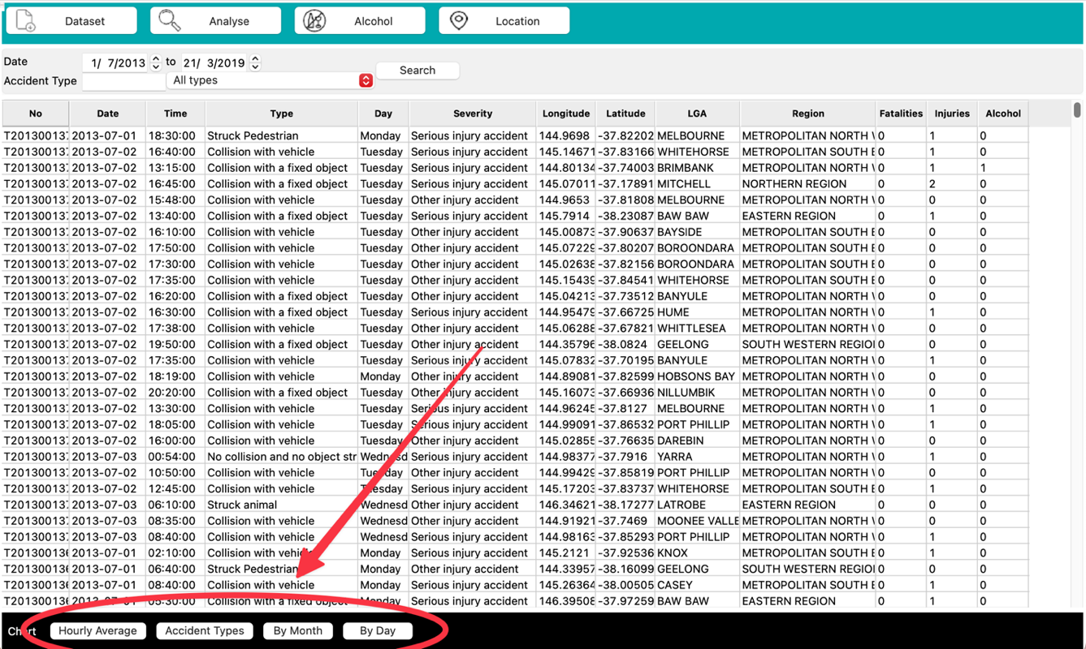

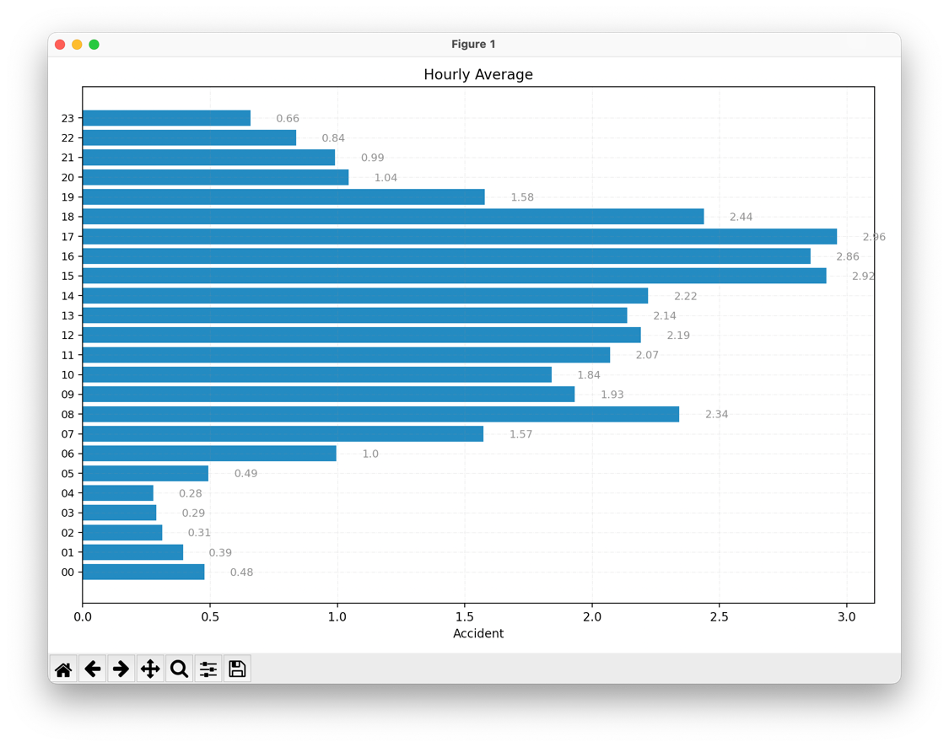

Click the file button at the bottom of the chart window to save the chart as an image file.

## Chart Examples

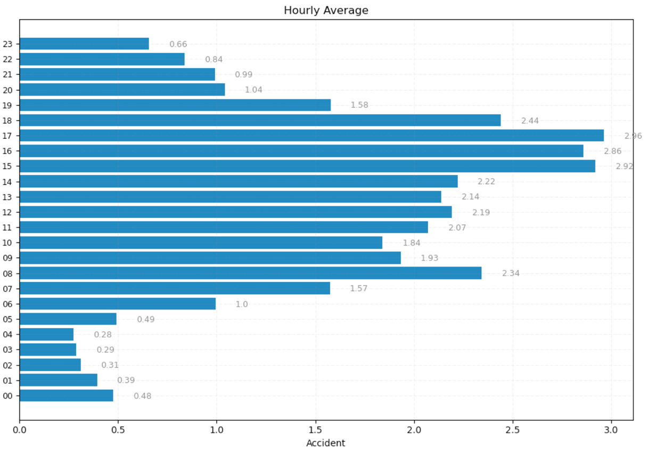

### Hourly Average Chart

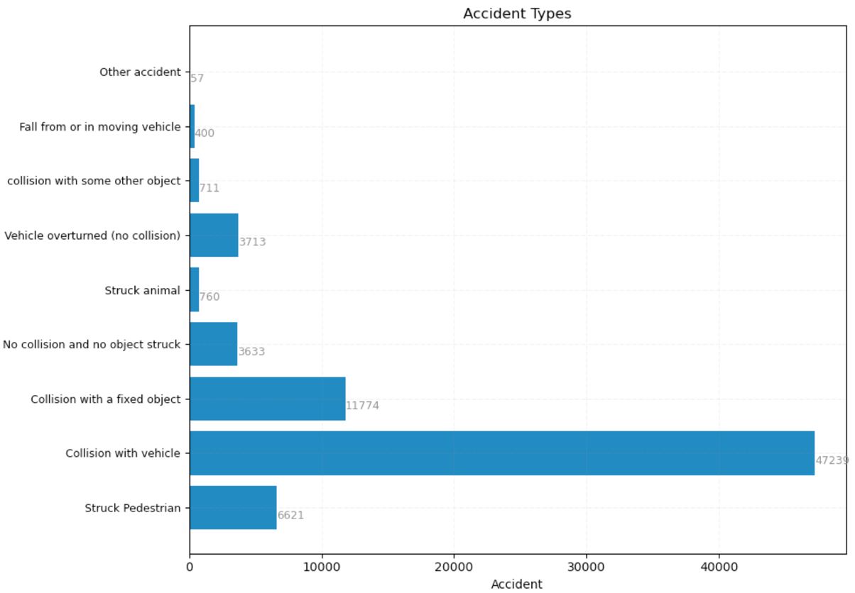

### Accident Type Chart

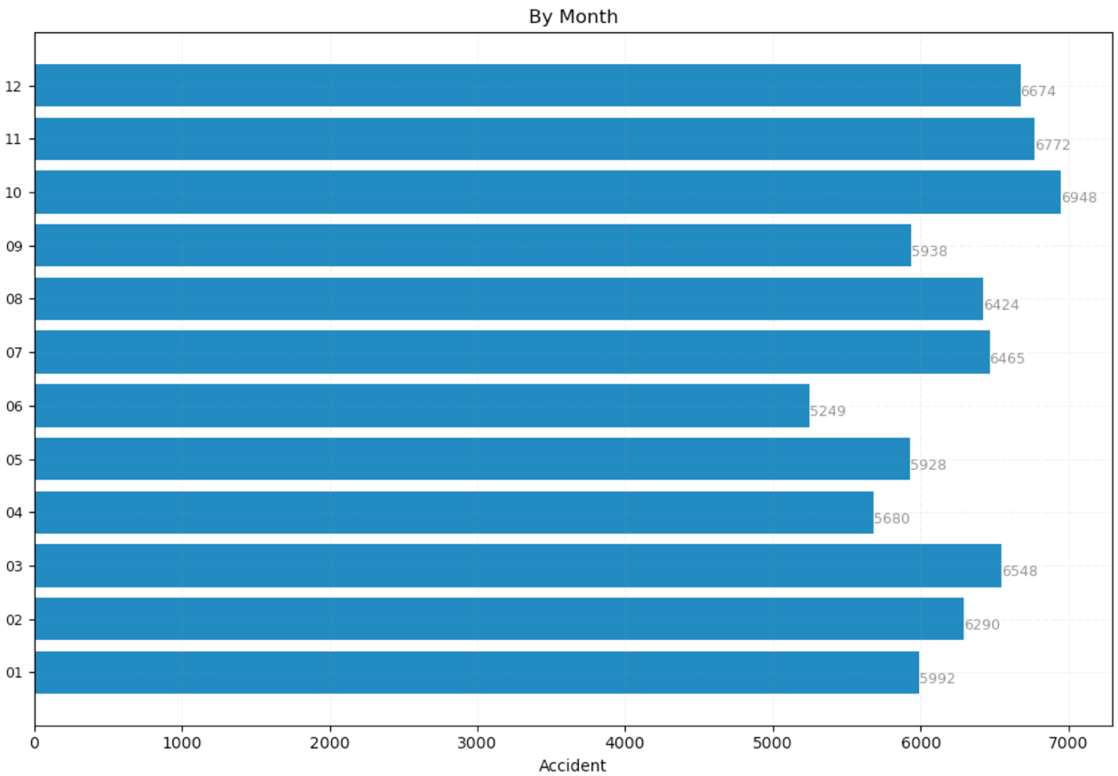

### By Month Chart

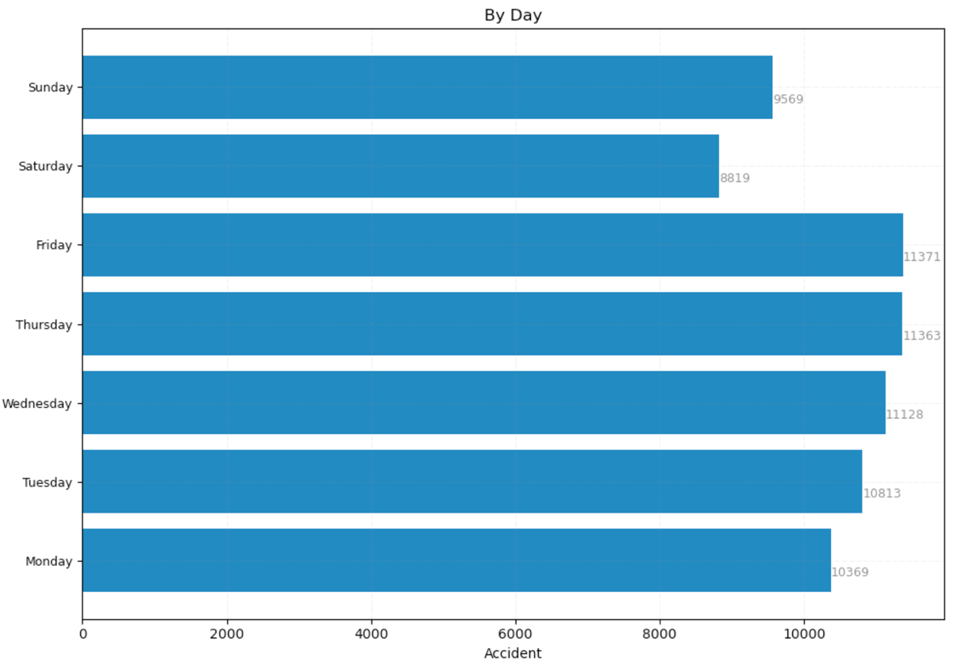

### By Day Chart

# Analyse Dataset: Alcohol

## Click on Alcohol button

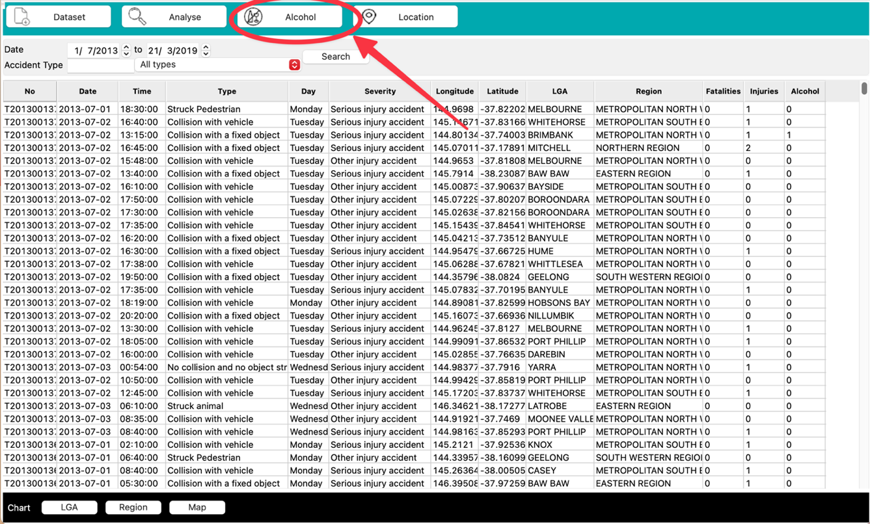

## Explore Chart Options for Alcohol Related Incidents

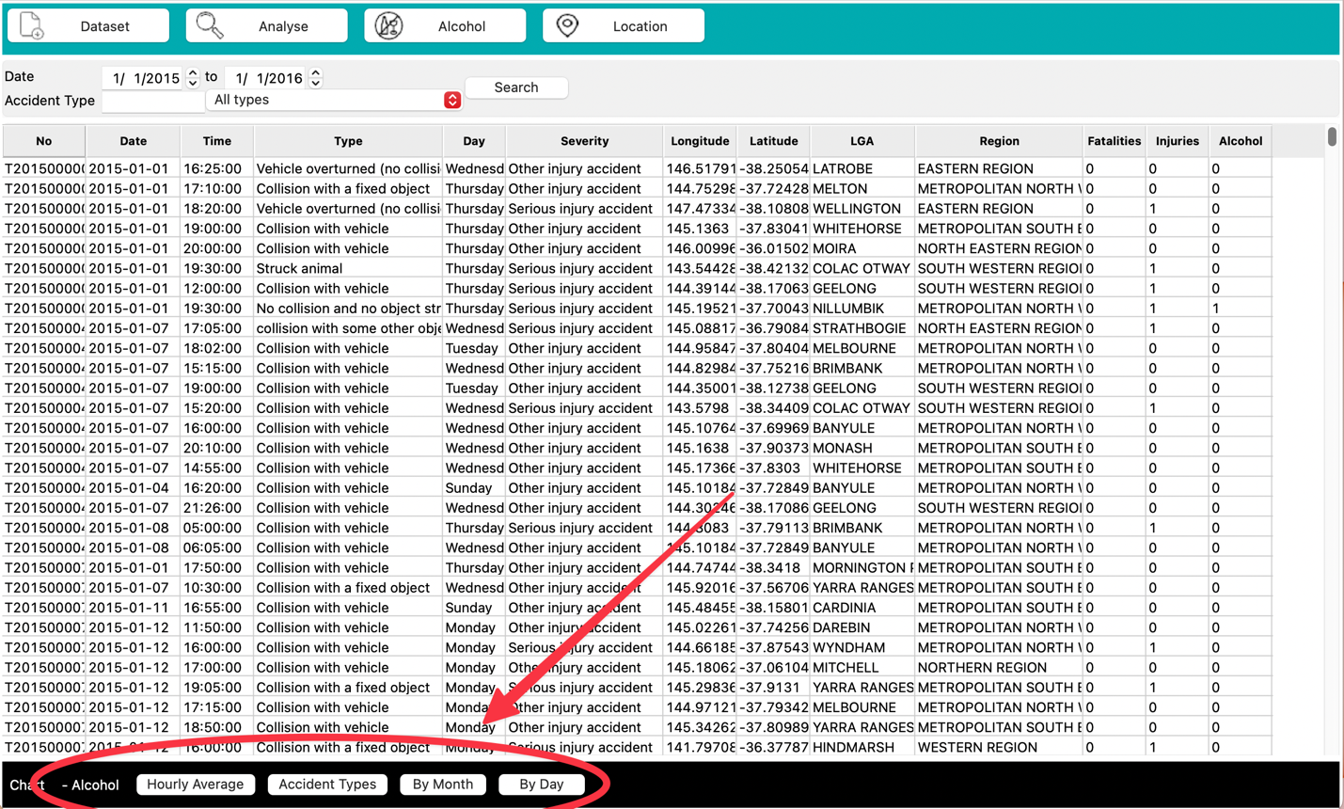

## Chart Examples

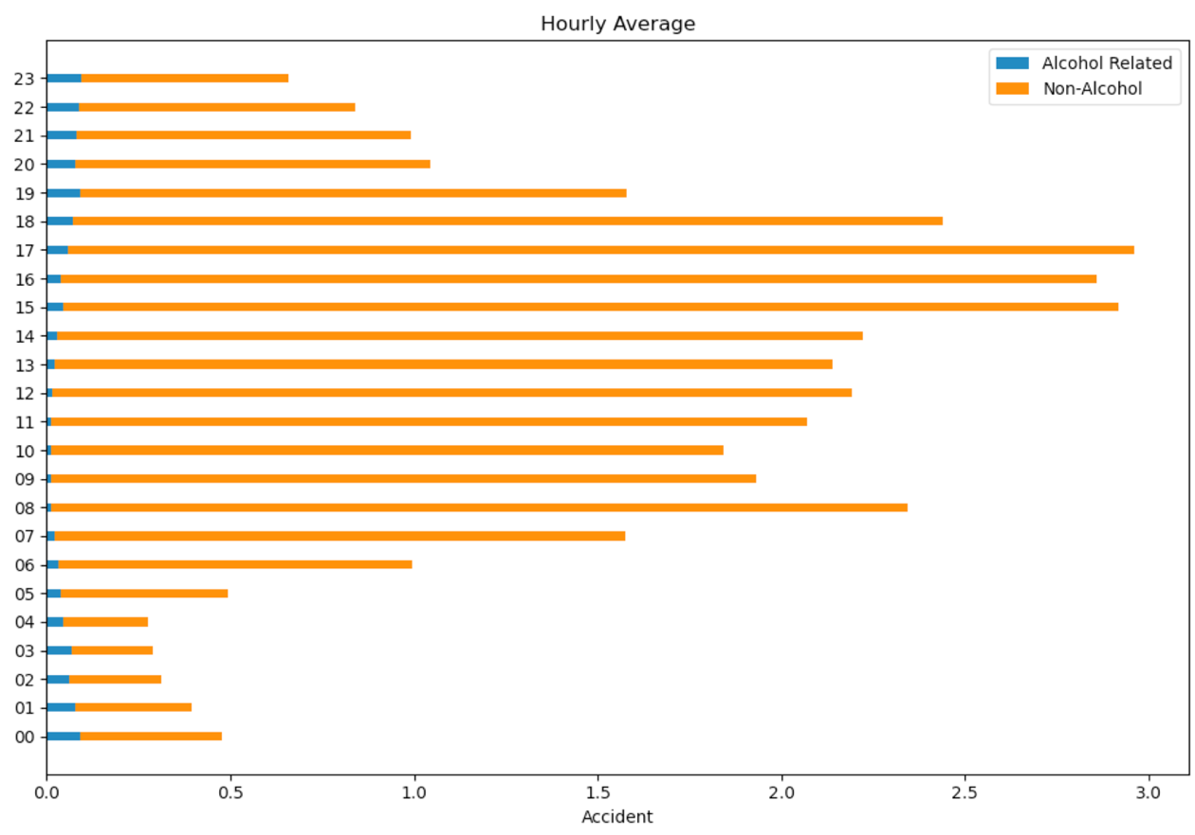

### Hourly Average chart including alcohol related incidents

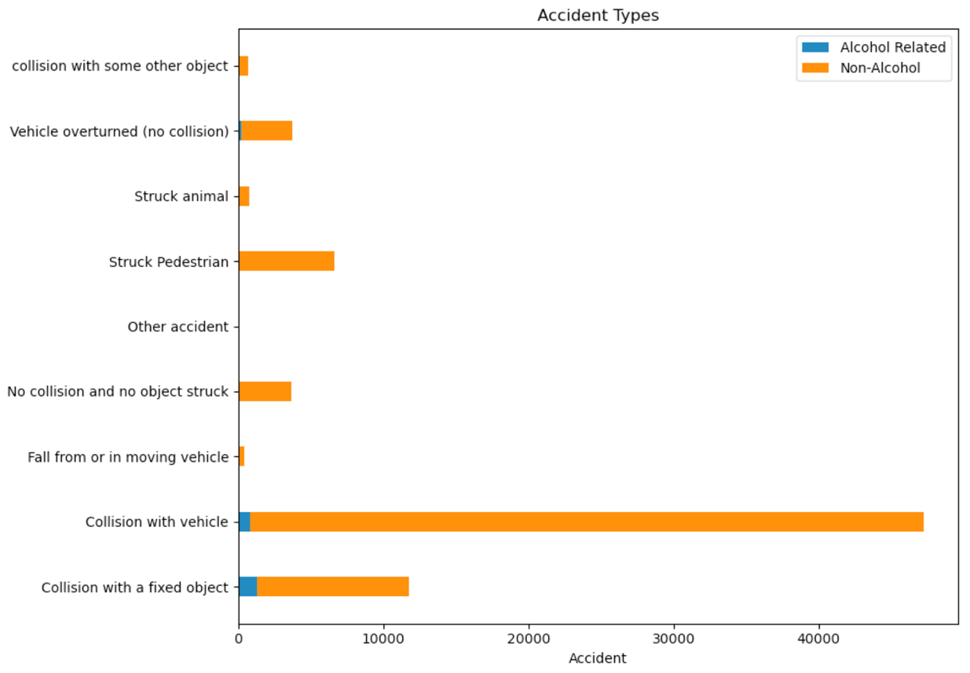

### Accident Types chart including alcohol related incidents

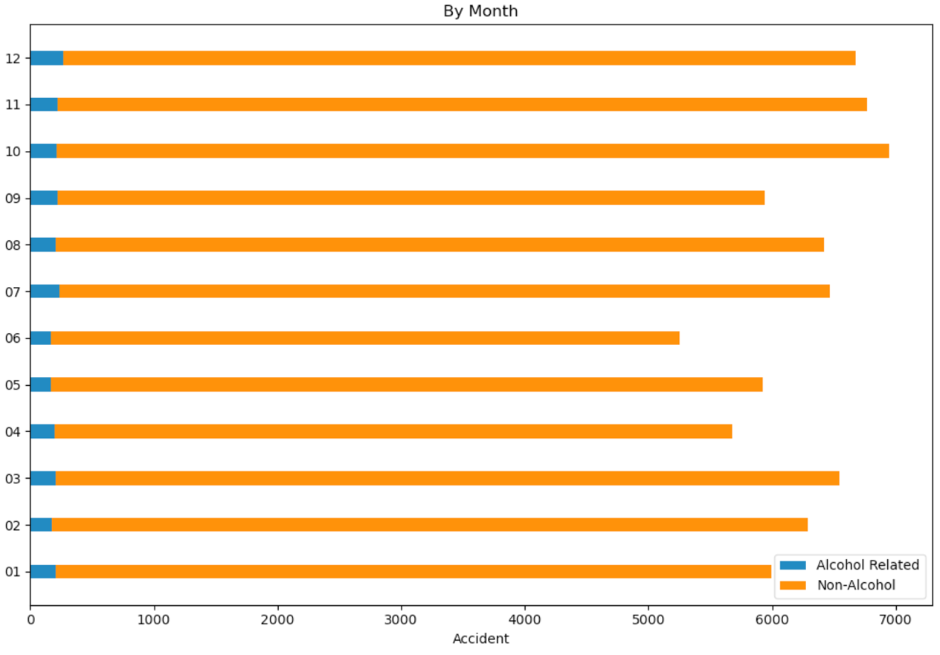

### By Month chart including alcohol related incidents

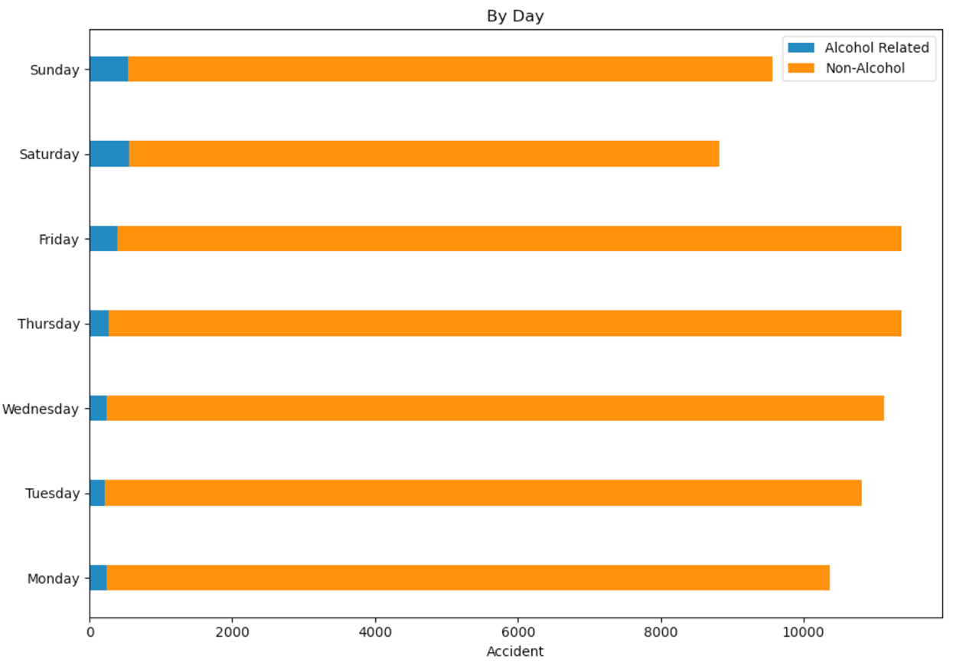

### By Day chart including alcohol related incidents

# Analyse Dataset: Location

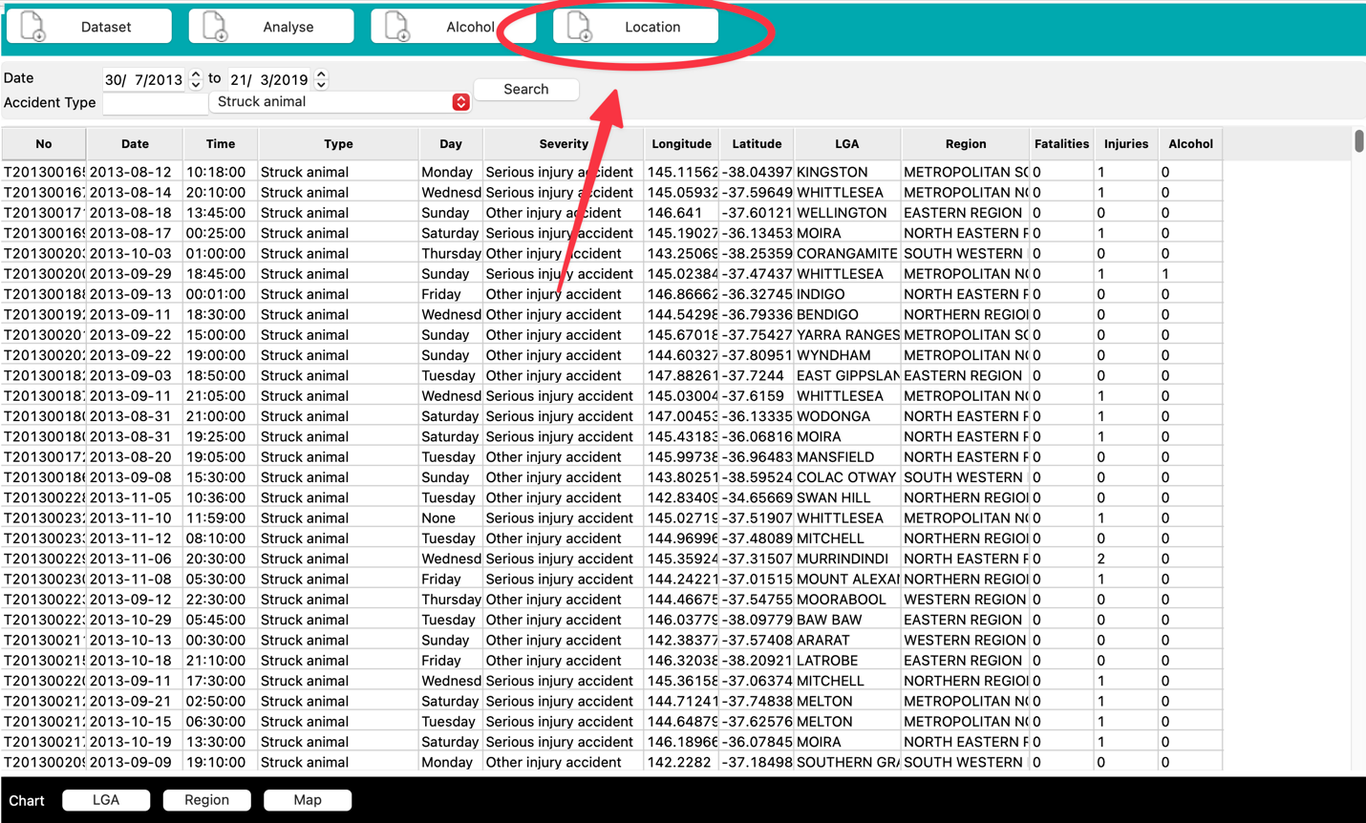

## Explore Chart Options for All Incidents via Location

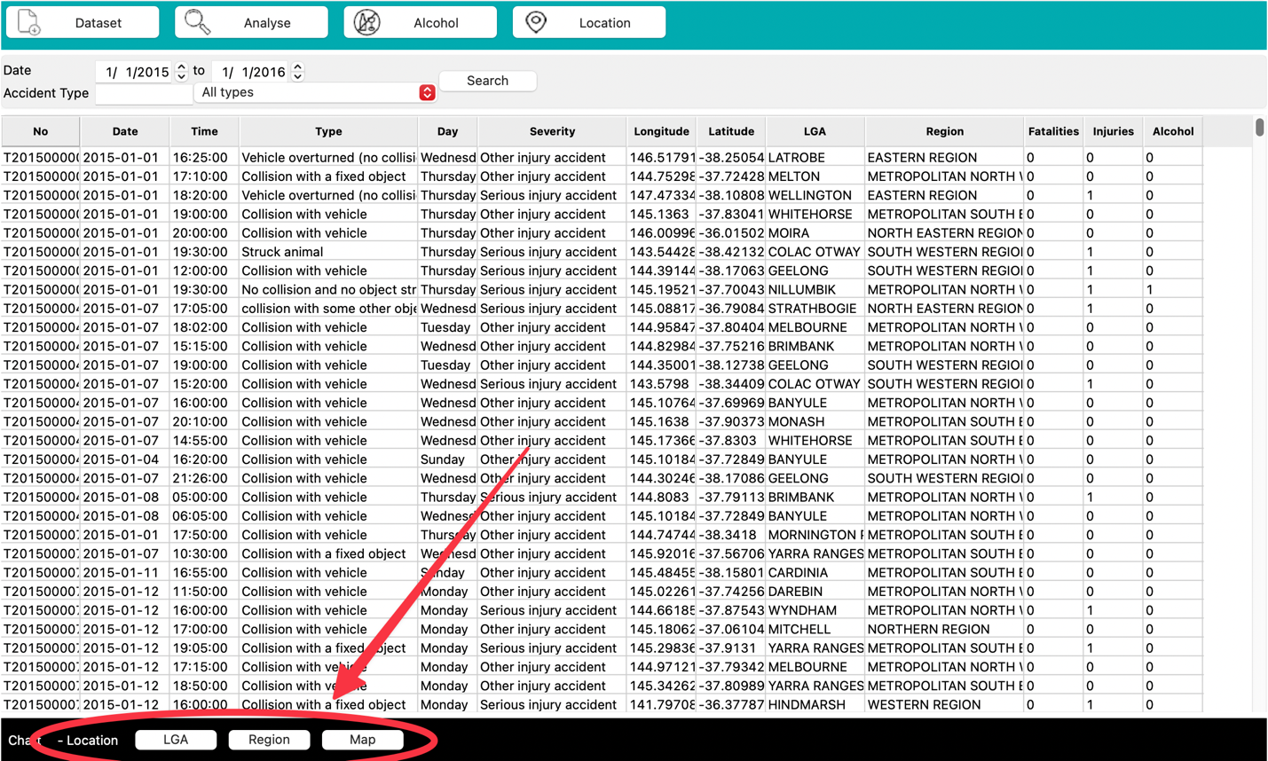

## Chart Examples

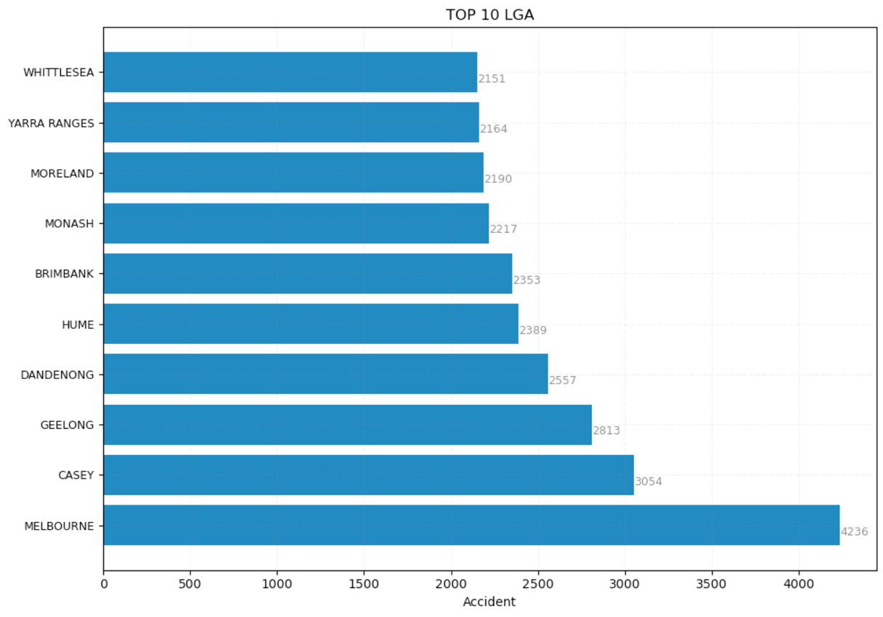

### Top 10 LGA Chart

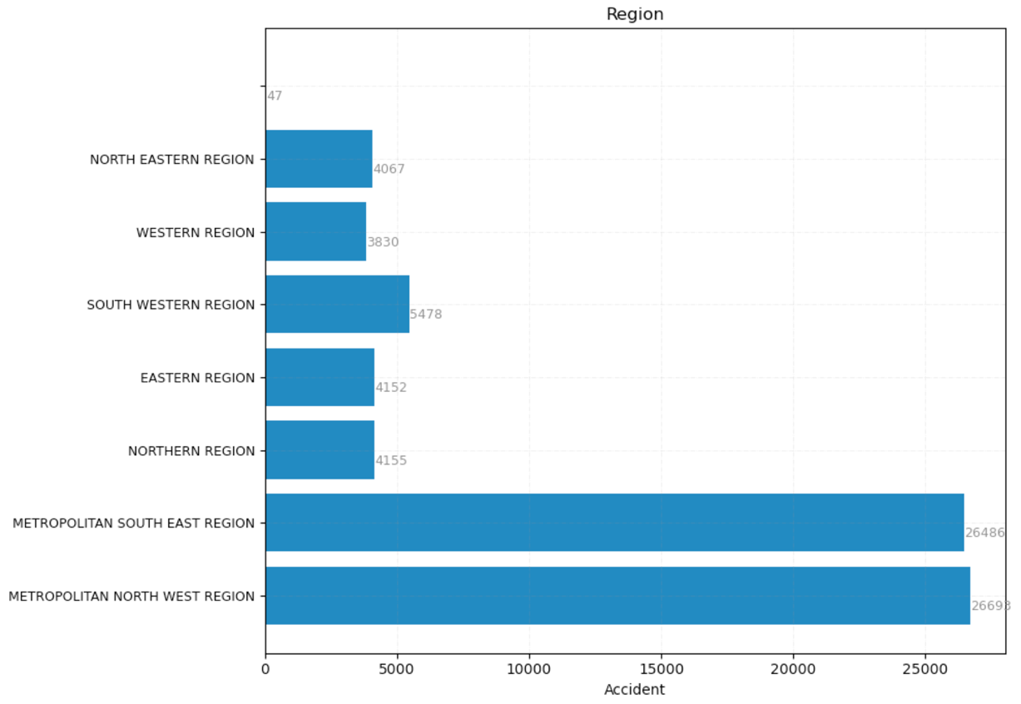

### Region Chart

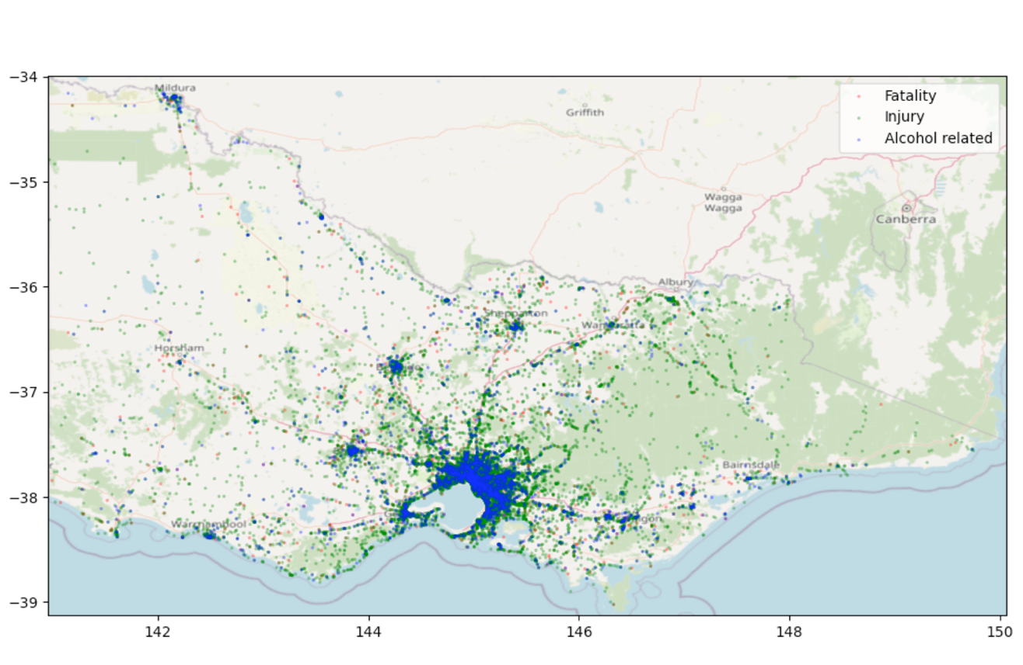

### Map Chart